PS–21 Second Fall Institute Day 2013- 2014
Friday, November 8, 2013
University of Alabama, 3408 SEC, Tuscaloosa AL

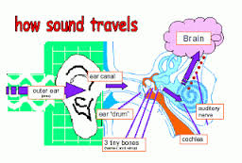
- 8:30 am: Registration, coffee, agenda, Institute surveys, PS-21 update, and concept pre-tests
- 9:00-10:50: Concept–1) Principles of sound and waves + engaging students with hands-on strategies & sharing ideas
- 10:50 – 11:00: Break
- 11:00-11:40: Concept–1 Continued) Inquiry lesson planning of lessons with sound using the Common Core and NGSS + developing lessons to motivate and engage students in learning ideas
- 11:40 – 12:40: Lunch
- 12:40-2:30: Concept–2) Using kinetic theory to explain states of matter, phase changes, solubility, and chemical reactions + engaging students with hands-on strategies & sharing teaching/learning ideas
- 2:30– 2:40 Break
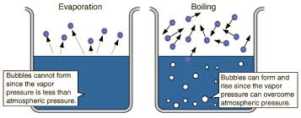
- 2:40– 3:25 Concept–2 Continued) Inquiry lesson planning with the Common Core and NGSS + developing lessons to motivate and engage students with hands-on strategies & sharing ideas
- 3:25– 3:45: Wrap up, Institute surveys, Feedback, content post-tests

